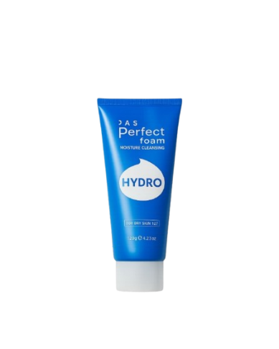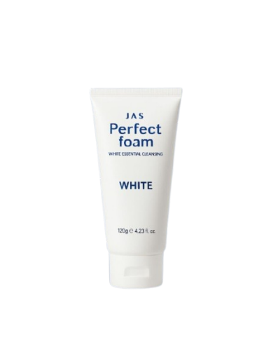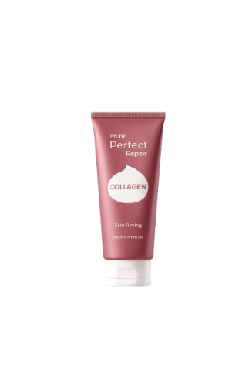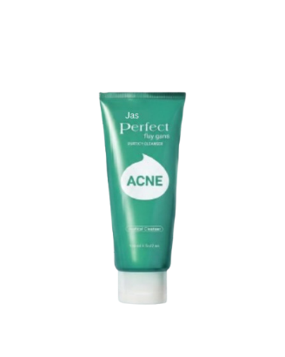
Name : Jas perfect
Jas perfect foam moisture cleansing
- Hydro
- White
- Acne
- Collagen
Description :
Jas Perfect Foam is a gentle facial cleanser that creates a soft, foamy lather to remove dirt, oil, and makeup from your skin. It leaves your face clean, fresh, and smooth without feeling tight or dry.
How to use :
Wet your face with water.
Squeeze a small amount of the foam onto your palms.
Gently massage the foam onto your face in circular motions.
Rinse thoroughly with water.
Pat dry with a towel.

